**CITY UNIVERSITY OF HONG KONG**

Course Code & Title: **GE2318**

**Complexity in Science and Engineering**

Session: Semester B 2023/24

This is a **closed-book** Test on Wednesday March 6, 2024

You have **60 minutes (1:30 - 2:30pm)**

**\* Student Name: ______________________**

**\* Student ID: _________________________**

Answer **all** questions.

**Directly write/draw on this hard copy of the test paper.**

Answering this exam paper implies your acknowledgment of the **Pledge** for following the **Rules on Academic Honesty**:

“I pledge that the answers in this examination are my own and that I will not seek or obtain an unfair advantage in producing these answers. Specifically,

1. I will not plagiarize (copy without citation) from any source;
2. I will not communicate or attempt to communicate with any other person during the examination; neither will I give or attempt to give assistance to another student taking the examination; and
3. I will use only approved devices (e.g., calculators) and/or approved device models.
4. I understand that any act of academic dishonesty can lead to disciplinary action.”

**Directly write/draw on this hard copy of the test papers and then hand-in**

To avoid triviality, assume that networks are simple, connected, with size $N≥3$, and assume that if not specifically indicated then all networks are undirected.

**Question 1 [40 Marks]** (Graph Theory, Network Models and the Internet)

**Q-1.1 [10 Marks]** Answer the following questions (**No need** to explain) [2 marks each]

(1) It is impossible for a network to have a total node-degree equal to 101.

**Answer:** True or False

(2) A fully-connected network is a small-world network.

**Answer:** True or False

A fully-connected network is a scale-free network.

**Answer:** True or False

(3) A square lattice is a random-graph network. **Answer:** True or False

A square lattice is a scale-free network. **Answer:** True or False

(4) A square lattice is a Eulerian network. **Answer:** True or False

A square lattice is a Hamiltonian network. **Answer:** True or False

(5) A square lattice is strong against random edge-removal attack.

**Answer:** True or False

A square lattice is strong against targeted node-removal attack.

**Answer:** True or False

**Q-1.2 [10 Marks]** Answer the following questions (**No need** to explain) [2 marks each]

(1) For a directed Hamiltonian graph, its underlying graph is undirected Hamiltonian.

**Answer:** True or False

(2) There are $N$ students in a class. Suppose that the probability for any pair of two students to become friends is $p=0.5$. The number of possible friendships in the class = ____

(3) Our mobile phones are part of the Internet.

**Answer:** True or False

(4) Our emails are sent from PCs or mobile phones to the communication satellites, which are then transmitted back to earth to the designated receivers.

**Answer:** True or False

(5) Phase synchronization between two signals completely ignores the signal

magnitudes.

**Answer:** True or False

**Q-1.3 [10 Marks]** Answer the following questions (**No need** to explain) [2 marks each]

(1) The most important property of a small-world network is: ___

(2) The main mechanism that generates the scale-free network model is: ___

(3) A network with a power-law node-degree distribution is called “scale-free” because: ___

(4) In the earlier 1980s, the small Internet could only do two major jobs, which are:

(i) _________________ and (ii) ________________

(5) In terms of devices, the basic structure of the Internet has three layers:

(i) highest: ___________ (ii) middle: ___________ (iii) lowest: ___________

**Q-1.4 [10 Marks]** Consider the graphs A), B), C), D) shown below [2 marks each]

List all possible answers to each question [such as: A), D), etc. **No need** to explain]

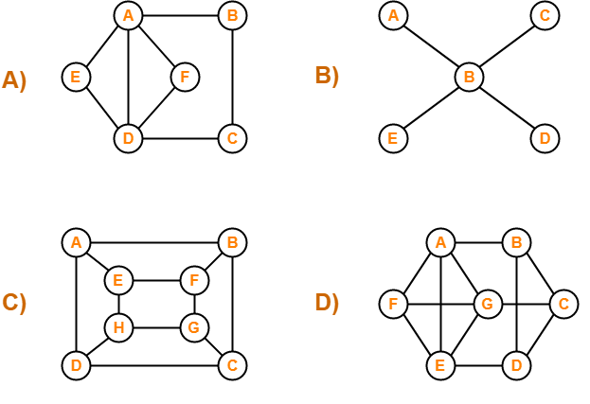

(1) Eulerian graph(s): ____________

(2) Semi-Eulerian graph(s): ______________

(3) Hamiltonian graph(s) ____________

(4) Semi-Hamiltonian graph(s): ____________

(5) None of the above: ______________

**Q2 [30 Marks]** (Network Spreading, Cascading Failures and Robustness)

**Q-2.1** [10 Marks] The SIS epidemic spreading model has a solution as follows, where $λ$ is the infection rate, $δ$ is the recovery rate, and $I(t)$ is the percentage of infected people in the population:

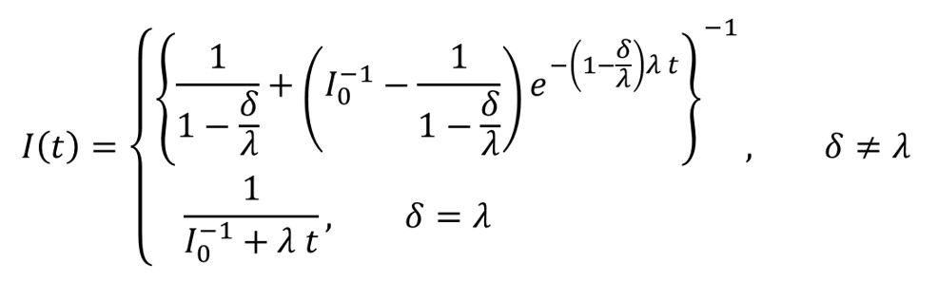

(i) [2 marks. **No need** to explain] If $δ>λ$, then $I\left(t\right)→$________ as $t→∞$.

(ii) [2 marks. **No need** to explain] If $δ=λ$, then $I\left(t\right)→$________ as $t→∞$.

(iii) [2 marks. **No need** to explain] If $δ<λ$, then $I\left(t\right)→$________ as $t→∞$.

(iv) [2 marks. **No need** to explain] If $δ≪λ$, then $I\left(t\right)→$________ as $t→∞$.

[2 marks. Explain] What does your result mean in life reality?

**Answer:** ____

**Q-2.2** [10 Marks] Consider the 5-node power grid shown below:

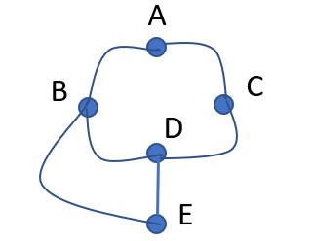

Assume that the overloading collapsing threshold is $φ=10$ for every node.

Initial loads: Nodes A has 9, B has 2, C has 1, D has 5, E has 9.

Now, an extra load $σ=3$ is added to Node A.

(1) [6 marks. 2 marks for each slot] Find the collapsing sequence:

A 🡪 _____ 🡪 _____ 🡪 _____ 🡪 _____

(2) [4 marks] Show a sketch of your calculations:

**Q-2.3** [10 Marks] Consider a group of 7 students, A, B, C, D, E, F, G, where

A: Speaks English

B: Speaks Chinese and English

C: Speaks English, Italian and Russian

D: Speaks Chinese and Japanese

E: Speaks German and Italian

F: Speaks French, Japanese and Russian

G: Speaks French and German

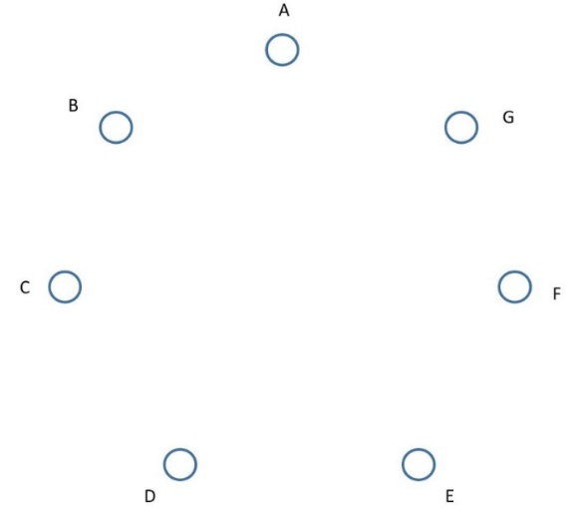

(1) [5 marks] Connect them to be friends such that every pair of friends can speak the same language. Directly draw your suggested connections on the figure.

(2) [5 marks] What kind of graph do you obtain (fully-connected, ring, tree, bipartite, lattice, Eulerian, Hamiltonian, …)? **Answer:** ____

**Q-3 [30 Marks]** (Network Analysis, Synchronization, Control and Applications)

**Q-3.1** [10 Marks] Consider the following graph (**No need** to explain) [2 marks each].

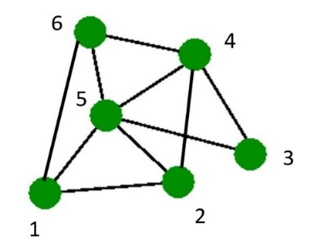

(1) Coreness of the graph = ______

(2) Node 6 will connect to which node(s)?

If based on degree similarity: ______. If based on distance similarity: ______

(3) Density of the graph = _______

(4) Is it an Eulerian graph? _______. Is it a Hamiltonian graph? _______

(5) If you can move one edge to somewhere, so as to improve the network synchronizability, which edge will you move and where will you move it to?

Why will you do so?

**Answer:** Move the edge between Node ____ and Node ____

to connect Node _____ and Node _____

**Explain:** ___

**Q-3.2** [10 mark] (Minimum connector problem)

Consider the computer network shown below (**No need** to explain):

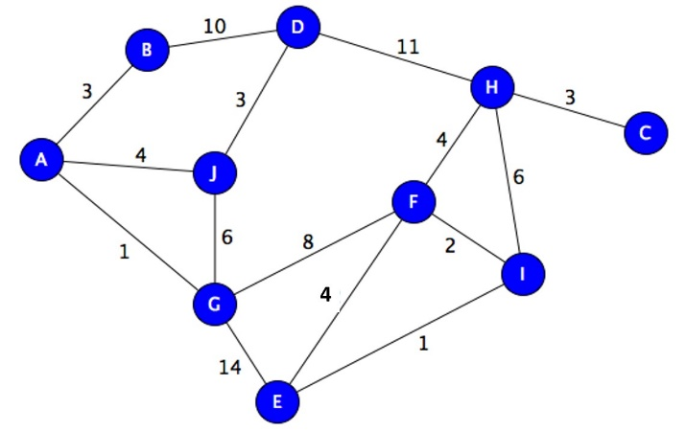

(1) [5 marks] Find a spanning tree with the minimum total path-length.

Directly mark your answer on the figure.

(2) [5 marks] Minimum total path-length = ______________

**Q-3.3** [10 marks] (Chinese postman problem)

Consider the street map shown below.

(1) [5 marks] Find the shortest path for the postman. Directly mark on the map.

(2) [5 marks] The shortest total extra street length = _____

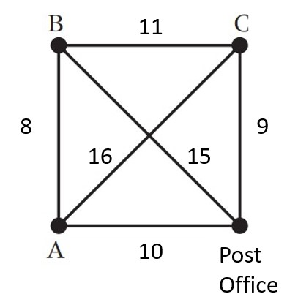

**--- Do not write on this page ---**

**Scores**

|  |  |  |
| --- | --- | --- |
| **Q-1.1** | 10 |  |
| **Q-1.2** | 10 |  |
| **Q-1.3** | 10 |  |
| **Q-1.4** | 10 |  |
|  |  |  |
| **Q-2.1** | 10 |  |
| **Q-2.2** | 10 |  |
| **Q-2.3** | 10 |  |
|  |  |  |
| **Q-3.1** | 10 |  |
| **Q-3.2** | 10 |  |
| **Q-3.3** | 10 |  |
|  |  |  |
| **Total** | **100** |  |